Developing an Interactive Healthcare Dashboard for Clinical Insights
Work-In-Progress
Mirna Elizondo
Computer Science Department, Texas State University, San Marcos, TX, USA, m_e172@txstate.edu
Dr. Jelena Tešić*
Computer Science Department, Texas State University, San Marcos, TX, USA, jtesic@txstate.edu
Dr. Monica Hughes*
St. David’s School of Nursing, Texas State University, San Marcos, TX, USA, monica.hughes@txstate.edu

* Associate Professor
ABSTRACT

CCS CONCEPTS
• Insert your first CCS term here • Insert your second CCS term here • Insert your third CCS term here
KEYWORDS
Insert comma delimited author-supplied keyword list, Keyword number 2, Keyword number 3, Keyword number 4
- Introduction
Health disparities in rural areas of Texas are influenced by multiple factors, including limited access to healthcare, socioeconomic barriers, and workforce shortages. Addressing these disparities requires not only access to healthcare data but also the ability to analyze it effectively to uncover hidden trends and disparities. The HAILE project aims to bridge this gap by developing an AI-powered interactive dashboard that aggregates multiple data sources to identify healthcare trends among comorbid patients. Existing healthcare dashboards primarily focus on patient records and administrative data management, which serve important functions but often lack the necessary tools for predictive analytics and interactive visualizations. The HAILE dashboard differs by focusing on real-time analysis through user-friendly visualizations and AI-driven insights. This project targets healthcare professionals, particularly nursing students and public health professionals, enabling them to make data-driven decisions and address the health needs of rural communities.
The dashboard is built around three core components: (1) Aggregating diverse datasets (CMS, EHR, social health determinants data, etc.). (2) Implements Comorbidity, HFRS, and Disability and Impairment Scores and calculates Absolute and Relative Index Disparity, Population Weighted and Attributable Disparity (3) Developing an intuitive dashboard tailored for healthcare practitioners. This paper outlines the current progress, methodology, and future steps for the HAILE project.

- Methodology

2.1 Data Integration
The dashboard aggregates structured and unstructured data from various public health sources, including:
- Centers for Medicare & Medicaid Services (CMS) OASIS Dataset: This dataset is used to analyze healthcare utilization, access, and outcomes for home health patients, focusing on comorbidities and their impact on patient care.
- OpenDataSoft Georef United States ZC Point Dataset: Provides geographic data at the ZIP code level, offering insights into regional healthcare access.
- 2020 Census Urban Area to County Dataset: Includes demographic data such as population size, housing counts, and urban/rural designations, which help in analyzing disparities based on geographic location.
- Social Determinants of Health (SDOH) Data: Incorporates factors like income, education, and employment that affect health outcomes, allowing for a more comprehensive view of patient populations.
Table 1: Dataset Overview and Utilization.
Name | Rows | Columns | Columns Used
CMS OASIS | 15,754,330 | 271 | 27
OpenDataSoft Georef | 2661 | 15 | 4
2020 Census UA | 3234 | 33 | 10
SDOH | 85529 | 329 | 70
To harmonize and preprocess data from these diverse sources, we employ Python-based ETL (Extract, Transform, Load) pipelines. These pipelines ensure data normalization and integration, utilizing packages such as comorbidipy for calculating comorbidity, hospital frailty, and disability and impairment scores, and simple-icd-10-cm for extracting ICD-10 code descriptions and hierarchical relationships (e.g., parents, children, descendants).
- Filtering and Aggregating Data: The initial step focuses on filtering the dataset for Texas-specific records. Once this is completed, data from all relevant sources is aggregated into a unified structure.
- Creating Condition Labels: Condition labels are created for key comorbidities, including diabetes, renal failure, hypertension, and heart failure. These are identified by matching ICD-10 codes across various diagnosis columns. After labeling the conditions, the dataset is filtered to isolate diabetic patients (n = 133,284).
- Categorizing BMI: For diabetic patients, the Body Mass Index (BMI) is categorized into specific groups based on the following thresholds:
  - Underweight: BMI < 18.5
  - Normal weight: 18.5 <= BMI < 24.9
  - Overweight: 25 <= BMI < 29.9
  - Obesity (Class 1): 30 <= BMI < 34.9
  - Obesity (Class 2): 35 <= BMI < 39.9
  - Obesity (Class 3): BMI >= 40
- Calculating Health Scores and Disparities: After BMI categorization, additional health scores are calculated, including the Comorbidity Score, Heart Failure Risk Score (HFRS), and Disability & Impairment Scores, which help assess the overall health and risk factors for each patient. Furthermore, disparity metrics are computed using data related to Social Determinants of Health (SDOH) topics such as educational attainment, English fluency, internet connectivity, living conditions, and poverty. These metrics include: AbsoluteIndexDisparity, RelativeIndexDisparity, PopulationWeightedIndexDisparity, PopulationAttributableProportion.
These metrics are critical for understanding health disparities and their potential impact on different populations, providing insights into how social and environmental factors contribute to health outcomes.

2.2 AI & Visualization Approach
This project focuses on creating an interactive dashboard that visualizes key healthcare disparities by county in Texas. Using demographic data and various disparity indices, the dashboard offers visual insights into gender, race, discipline, BMI categories, and urbanization. The dashboard aims to assist policymakers, healthcare professionals, and researchers in making data-driven decisions for improving healthcare access and outcomes.

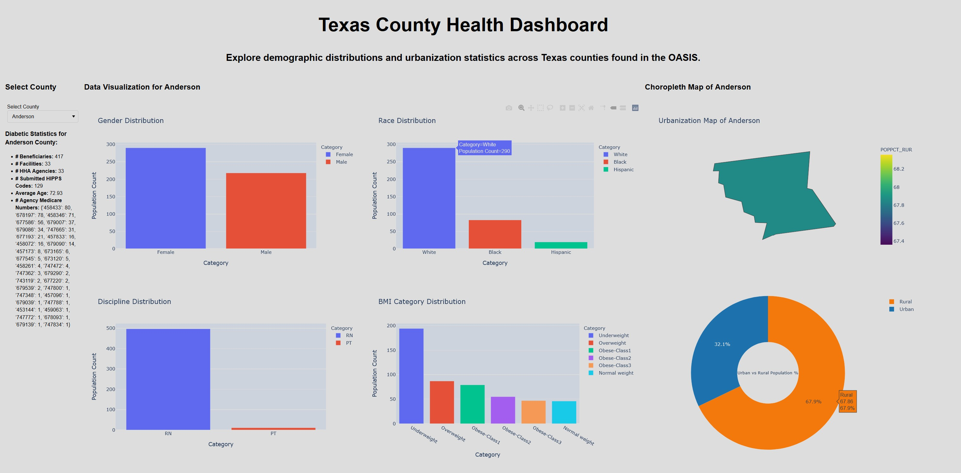
Figure 1: Texas OASIS County Health and Demographic Dashboard

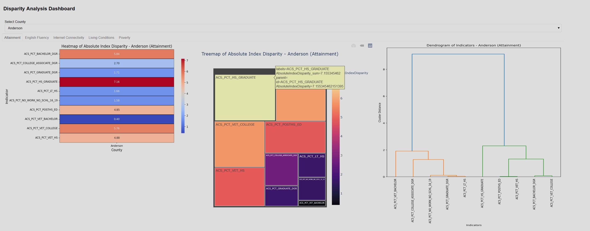
Figure 2: Disparity Analysis of Social Determinants of Health (SDOH) and Indicator Hierarchical Clustering

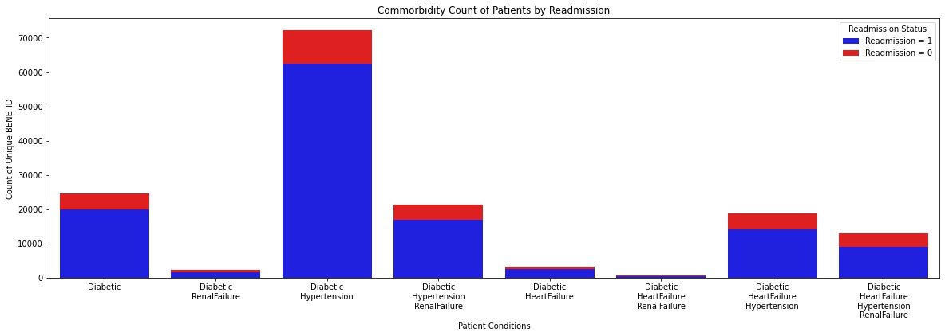
Figure 3: CMS OASIS Comorbidity Count of Patients by Hospital Readmission
2.3 User-Centric Design

The dashboard is designed with the user in mind, allowing for seamless interaction with the data. Users can select specific counties and view a wide array of interactive visualizations that respond dynamically to their selection. The intuitive interface includes a county selector widget, clearly labeled sections, and easily interpretable visualizations such as gender and race distributions, urban vs rural populations, and heatmaps of disparity indices. The design is aimed at making complex data accessible and actionable for policymakers, healthcare administrators, and researchers, enabling them to make informed decisions at both the regional and local levels.

3. Current Progress

Currently, the core components of the dashboard are fully functional. These include the interactive selection of counties, the display of demographic distributions (such as gender, race, and BMI categories), and the generation of choropleth maps to visualize urbanization levels. Additionally, the dashboard features several analytical visualizations, such as heatmaps, treemaps, and dendrograms, to provide insights into healthcare disparities based on various indices. The user interface has been designed and tested for ease of use, with responsive and interactive visual elements.

Our current focus is on the implementation of machine learning models, where the system preprocesses the data in real-time, handling categorical variables (e.g., gender, race) using one-hot encoding and numerical variables (e.g., age, BMI) using scaling, while training a Random Forest classifier on the selected features and evaluating its performance. The dashboard will display model accuracy, a classification report (precision, recall, F1-score), and feature importance scores, highlighting which clinical or SDOH features contribute most to predictions.

4. Future Work & Challenges
- User Testing & Feedback: Conducting usability studies with nursing students and community partners.
- Scalability & Deployment: Expanding dashboard functionalities and integrating real-time data updates.
- AI Model Refinement: Enhancing the predictive models with more sophisticated techniques, such as deep learning, for improved accuracy in predicting patient outcomes.

5. Conclusion

The HAILE project represents a significant advancement in the development of AI-powered healthcare dashboards that can help identify and mitigate health disparities in rural communities. The integration of diverse datasets and predictive modeling techniques offers a comprehensive approach to addressing the complex healthcare needs of comorbid patients. With further development, this dashboard has the potential to become a critical tool for public health professionals, aiding in evidence-based decision-making and improving patient care.
ACKNOWLEDGMENTS
This work was sponsored in part by the Texas State Center for Analytics and Data Science (TXST CADS) and the Applied AI Summer Workshop.
REFERENCES

[1] Centers for Medicare & Medicaid Services. OASIS Data Sets. Centers for Medicare & Medicaid Services, www.cms.gov/medicare/quality/home-health/oasis-data-sets.
[2] Elizondo, Mirna, et al. “AI/ML Pipeline for Predicting Diabetic Readmissions from CMS OASIS dataset.” IEEE International Conference on Big Data (IEEE BigData) 2024.
[3] U.S. Census Bureau. 2020 U.S. Census Urban Area (UA) to County Relationship File. U.S. Census Bureau, 2020, www2.census.gov/geo/docs/reference/ua/2020_UA_COUNTY.xlsx.
[4] OpenDataSoft. Georef United States of America ZC Point Dataset. OpenDataSoft, 2025, data.opendatasoft.com/explore/dataset/georef-united-states-of-america-zc-point%40public/export/?flg=en-us.
[5] Centers for Disease Control and Prevention (CDC). "BMI Categories." Centers for Disease Control and Prevention, 2025, www.cdc.gov/bmi/adult-calculator/bmi-categories.html.
[6] ICD10Data.com ICD-10-CM Codes. 2025, www.icd10data.com/ICD10CM/Codes.
[7] Social Determinants of Health Database | Agency for Healthcare Research and Quality, www.ahrq.gov/sdoh/data-analytics/sdoh-data.html. Accessed 13 Mar. 2025.
[8] “ICD-10 Codes Lookup, Diagnosis Codes Search - Codify by AAPC.” ICD-10 Codes Lookup, Diagnosis Codes Search - Codify by AAPC, www.aapc.com/codes/icd-10-codes-range/?srsltid=AfmBOoog5_u_SYP-InM8WmaLmuTMld2ifGbeOfkFiaALHsFRC8vKcko5. Accessed 17 Mar. 2025.
[9] Gasparini, Alessandro. “comorbidiPy.” GitHub, github.com/vvcb/comorbidipy?tab=readme-ov-file. Accessed 17 Mar. 2025.

